High performance & durable, record with confidence

[Watch Video](https://www.kingston.com/en/video/play?videoId=gBSxl1scdzDCgT7aoywvDsOo02vocNMxFFrXpbK-taTzpcyXYKdmMhuEUbkXnrykefnuu2Mmc_euvrLS313XZg2&start=0&autoPlay=False&chromeless=False&captionOption=No)

SDCE

* [Intro](https://www.kingston.com/en/memory-cards/high-endurance-microsd-card#product-features)
* [Specifications](https://www.kingston.com/en/memory-cards/high-endurance-microsd-card#specifications)
* [Resources](https://www.kingston.com/en/memory-cards/high-endurance-microsd-card#links)
* [Product Comparison](https://www.kingston.com/en/memory-cards/high-endurance-microsd-card#comparison-chart-1)
* [Datasheet](https://www.kingston.com/datasheets/sdce_us.pdf)

[**Buy**](https://www.kingston.com/en/memory-cards/high-endurance-microsd-card#atc)

High-Endurance microSD Memory Cardfor Security, Body and Dash Cams

Kingston’s High-Endurance microSD Card is built to withstand write-intensive applications such as professional & home surveillance cameras, dash cams and body cams. With 24/7 seamless recording and playback in Full HD 1080p1, it’s guaranteed to capture critical recordings when you need it the most. The High-Endurance microSD Card is engineered and tested for use in harsh conditions and is durable enough to protect itself from extreme temperatures, water, and x-rays2. Kingston High-Endurance microSD Cards are available in 32GB-256GB capacities and are backed by a three-year warranty, free technical support and legendary Kingston® reliability.

* 24/7 reliable recording1
* High-performance, seamless recording
* Durable in harsh conditions
* Save on monthly cloud storage fees by recording locally
* High endurance and reliability3

Key Features



Continuous Surveillance

24/7 recording for professional surveillance systems1



Seamless and reliable recording

Whether you are on the road or in the comfort of your own home, the Kingston High-Endurance microSD Card is guaranteed to capture thousands of hours of video on your dash cam or home security camera1



High endurance and reliability

Rated to endure 3K P/E cycles to meet requirements for a wide range of industrial applications with an optional health monitoring tool to manage the lifespan of the card3.

Compare microSD Cards

SDCS2

SDCG3

SDCE

SDCIT2



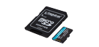

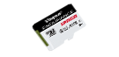

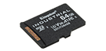

Name

Canvas Select Plus microSD

Canvas Go! Plus microSD

High-Endurance microSD

Industrial microSD

User

Consumer

Consumer

Consumer

Business/ Industrial

Capacity

64GB–512GB

64GB-1TB

32GB–256GB

8GB–64GB

Speed

100MB/s Read (64GB-128GB)  
100MB/s Read, 85MB/s Write (256GB-512GB)

•170MB/s read, 70MB/s write (64GB)  
•170MB/s read, 90MB/s write (128GB-1TB)

95MB/s Read, 30MB/s Write (32GB-64GB)  
95/MB/s Read, 45MB/s Write (128GB-256GB)

Up to 100MB/s Read, 80MB/s Write

Compatibility

UHS-I, U1, V10, A1 (64GB-128GB) UHS-I, U3, V30, A1 (256GB-512GB)

UHS-I, U3, V30, A2

UHS-I, U1, V10, A1

UHS-I Speed Class U3, V30, A1

Usage

• Point and shoot cameras  
• Android devices

• 4K Video Production  
• Action Cameras  
• Drones  
• Android Devices

• Dash cameras  
• Security cameras  
• Body cameras

• Designed and tested to be durable in extreme temperatures

[Learn more](https://www.kingston.com/en/memory-cards/canvas-select-plus-microsd-card)

[Learn more](https://www.kingston.com/en/memory-cards/canvas-go-plus-microsd-card)

[Learn more](https://www.kingston.com/en/memory-cards/high-endurance-microsd-card)

[Learn more](https://www.kingston.com/en/memory-cards/industrial-grade-microsd-uhs-i-u3)

 Reset Chart

 Remove

 Remove

 Remove

 Remove

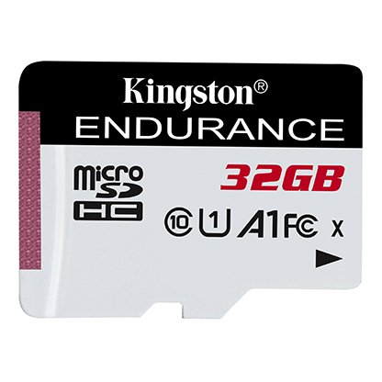

* [microSD SDCE](javascript:void(0))

Capacity

 32GB

 64GB

 128GB

 256GB

* Part Number: SDCE/32GB
* for home security, surveillance, body and dash cams
* UHS-I Speed Class 1 (U1)
* Up to 95MB/s read, 30MB/s write
* SD adapter not included

[**Where to Buy**](https://www.kingston.com/en/wheretobuy)

Specifications

|  |  |
| --- | --- |
| Capacities4 | 32GB, 64GB, 128GB, 256GB |
| Performance5 | UHS-I U1 Speed Class 10 A1 32GB & 64GB – 95MB/s Read and 30MB/s Write 128GB & 256GB – 95MB/s Read and 45MB/s Write |
| Endurance | 3K P/E Cycles Health Monitoring |
| Format | FAT32 for SDHC and exFAT for SDXC |
| Operating Hours | 26.9K hours (24/7 recording for 3-year warranty) |
| Dimensions | 11mm x 15mm x 1mm |
| Operating Temperature | -25°C to 85°C |
| Storage Temperature | -40°C to 85°C |
| Warranty | 3-year warranty, free technical support |